Experiment No. 8

Aim: Create a small machine-learning project whose tests, data/model validation and model-training workflow can be executed automatically as part of a Jenkins CI pipeline.

Tools:
- Python 3.
- Git/GitHub.
- Jenkins.
- Python packages: pandas, scikit-learn, joblib and pytest.
- Small tabular dataset or a generated dataset.
- Jenkins agent with the required Python environment.

Theory:
CI/CD automates building, testing, and deploying software on every code change. In traditional CI/CD: Code → Build → Test → Deploy. In ML CI/CD (MLOps), the flow becomes: Code/Data change → Retrain model → Evaluate metrics → Package artifact into container → Deploy inference API — since ML systems involve Code + Data + Model, not just code.
Jenkins is an automation server that runs these stages automatically. A Freestyle Project configures this entirely through Jenkins' Web UI (no Groovy/scripting needed) using dropdowns and shell/batch command boxes — beginner-friendly, unlike a Pipeline (Jenkinsfile) project which requires Groovy but is version-controlled.
In this experiment, Jenkins pulls code from GitHub, installs dependencies, trains a Random Forest model (train.py), runs automated tests (test_model.py) as a quality gate, then packages the model into a Docker image and deploys it as a running container — demonstrating the full MLOps lifecycle.
Steps Performed
- Created project files (train.py, test_model.py, requirements.txt, Dockerfile) in a local folder mlops-experiment.
- Pushed the project to GitHub:
git init
git add .
git commit -m "Initial ML CI/CD pipeline files"
git branch -M main
git remote add origin https://github.com/bhoomimali/mlops-experiment
git push -u origin main
- Started Jenkins on http://localhost:8080 (freed the port from XAMPP first).
- Created a New Freestyle Project:
New Item → named MLOps-Lab-Exp8 → selected Freestyle project → OK
- Linked the GitHub repository:
Source Code Management → Git → pasted repo URL
Set Branches to Build to */main
- Added Build Step 1 — Train & Test (Execute Windows batch command):
pip install -r requirements.txt
python train.py
python -m pytest test_model.py
- Added Build Step 2 — Docker Build & Run (Execute Windows batch command):
docker build -t ml-inference-app:v1 .
docker run -d -p 5000:5000 --name ml_app_container ml-inference-app:v1
- Saved and clicked Build Now. Console Output showed: Git checkout → dependencies installed → model trained (100% accuracy, model.pkl saved) → 2 pytest tests passed → Docker image built → container run successfully.
- Result: Finished — SUCCESS, confirming the complete pipeline (checkout → train → test → containerize → deploy) executed automatically without manual intervention.
Code:

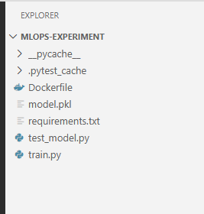
Train.py:

import joblib
from sklearn.datasets import load_iris
from sklearn.ensemble import RandomForestClassifier
from sklearn.model_selection import train_test_split

def train():
# Load dataset
iris = load_iris()
X_train, X_test, y_train, y_test = train_test_split(
iris.data, iris.target, random_state=42
)
# Train lightweight model
clf = RandomForestClassifier(n_estimators=10, random_state=42)
clf.fit(X_train, y_train)
# Evaluate basic accuracy
accuracy = clf.score(X_test, y_test)
print(f"Model Accuracy: {accuracy * 100:.2f}%")
# Save the model artifact
joblib.dump(clf, "model.pkl")
print("Model successfully saved as model.pkl")

if __name__ == "__main__":
train()
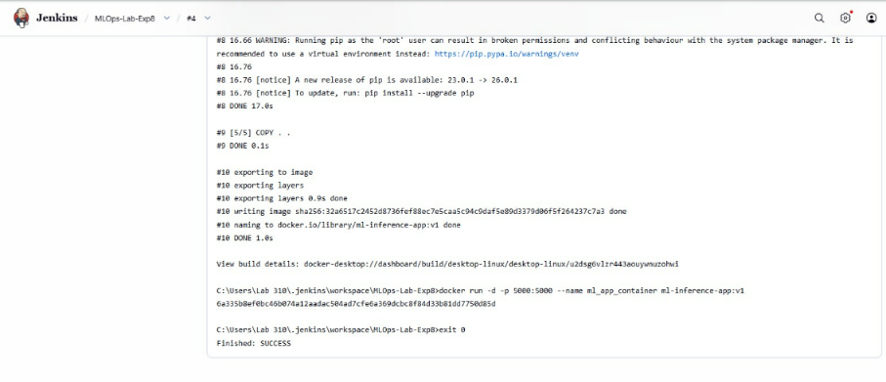
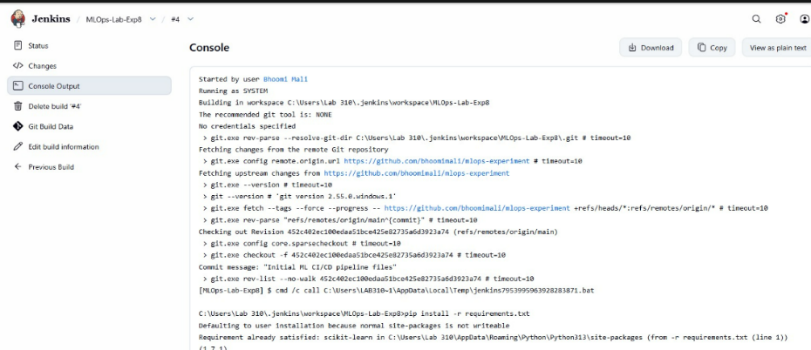

test_model.py:
import os
import joblib

def test_model_artifact_exists():
assert os.path.exists("model.pkl"), "Error: model.pkl artifact was not created."

def test_model_inference():
clf = joblib.load("model.pkl")
sample_input = [[5.1, 3.5, 1.4, 0.2]]
prediction = clf.predict(sample_input)
assert len(prediction) == 1, "Error: Model failed to generate a prediction."

Dockerfile:
FROM python:3.9-slim
WORKDIR /app
COPY requirements.txt .
RUN pip install --no-cache-dir -r requirements.txt
COPY . .
CMD ["python", "train.py"]
Output:

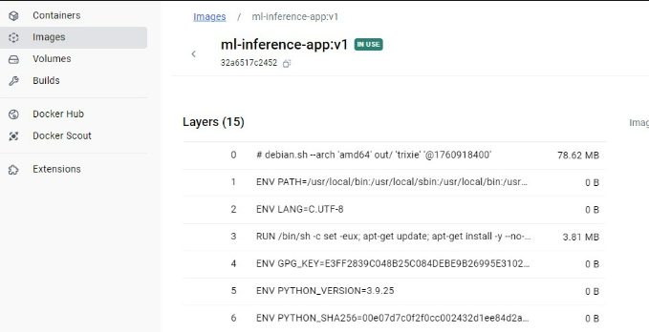
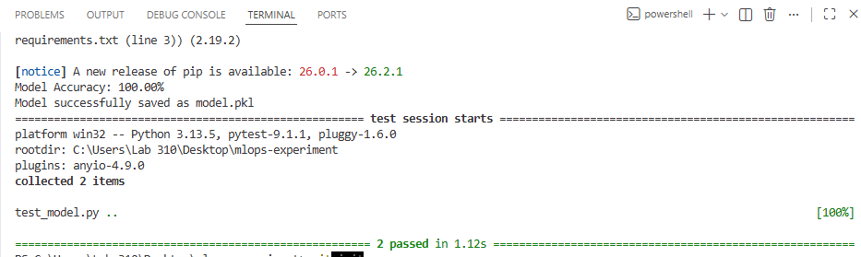

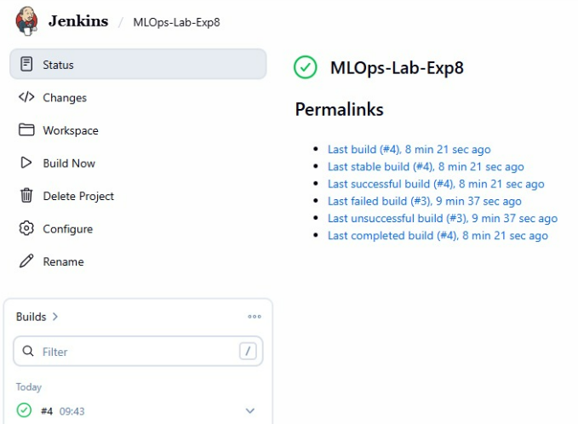
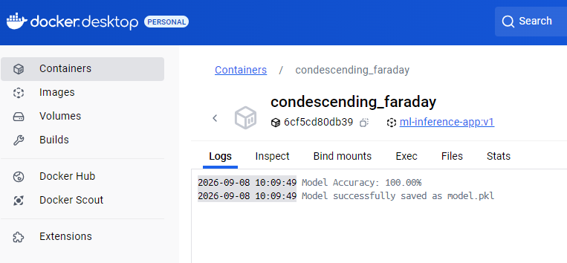

Learning Objective:
- Understand CI for machine-learning projects.
- Automate model training and validation.
- Use a model-quality gate in a pipeline.
- Store model artifacts with build records.

Conclusion:

For Faculty Use:

Correction | Formative | Timely | Attendance/
Parameters | Assessment | Completion | Learning
 | [40%] | of Practical | Attitude
 |  | [40%] | [20%]

